**Iteration and Selection**

Can you name 3 input devices?

1)

2)

3)

Can you name 3 output devices?

1)

2)

3)

Can you match the blocks with the statements?

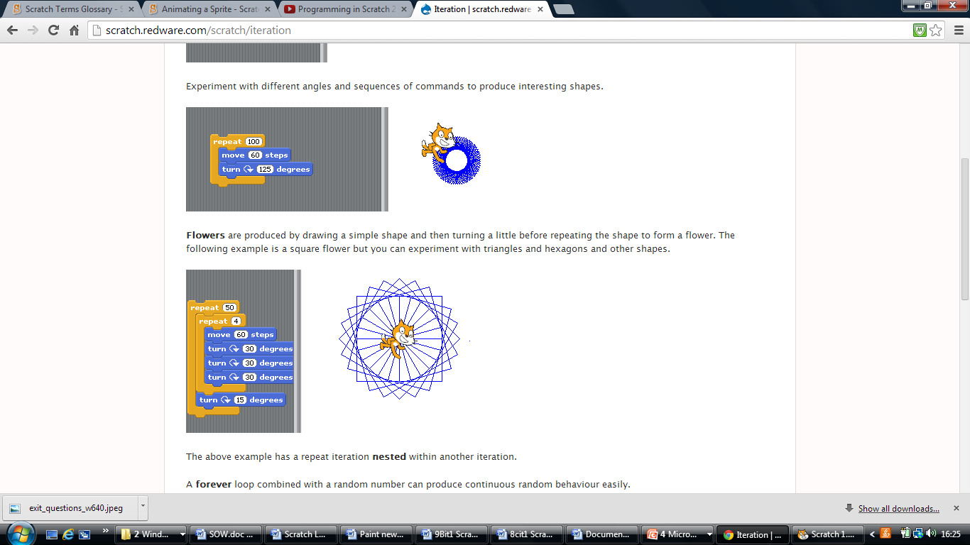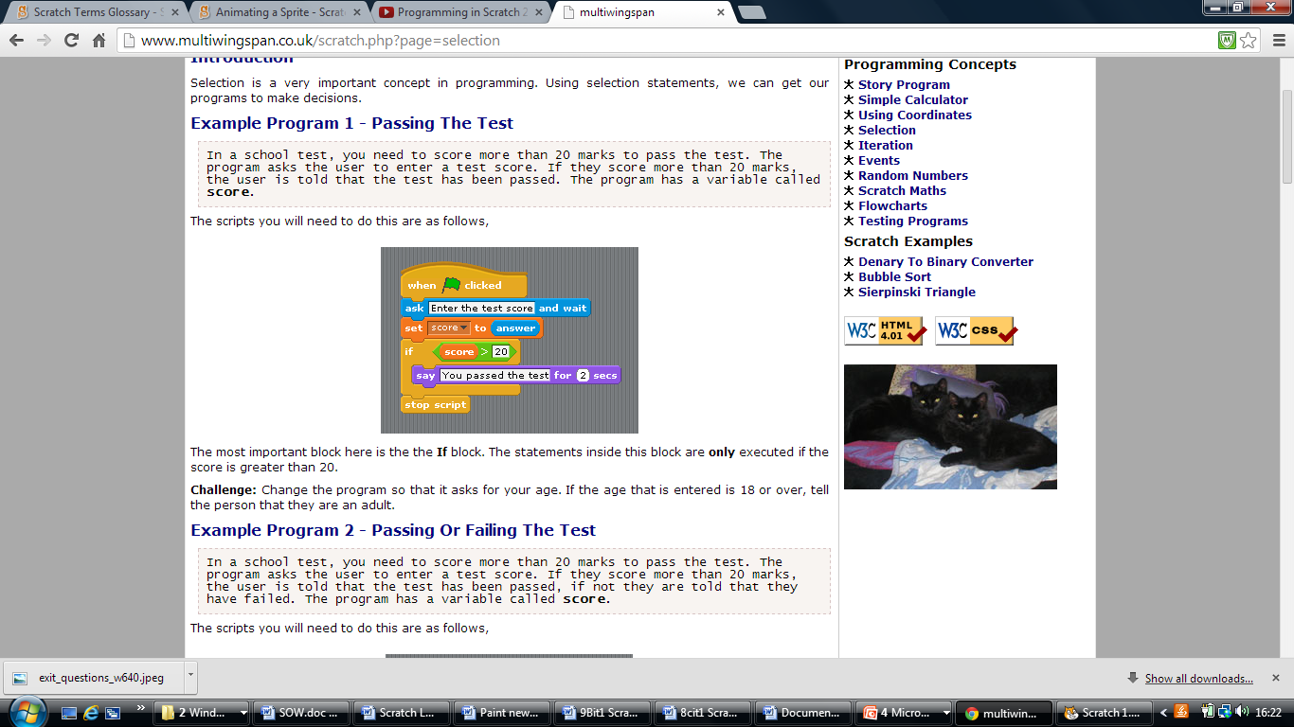



In a school test, you need to score more than 20 marks to pass the test. The program asks the user to enter a test score. If they score more than 20 marks, the user is told that the test has been passed. The program has a variable called**score**.

This has a loop nested with a second loop.